Press Release

June 25, 2019
For Immediate Release

Action-Horror-Western HIGH MOON Screams to DVD July 2nd
Chad Michael Collins and Sean Patrick Flanery Take on Werewolf Bikers in Genre-Bending Horror Film!
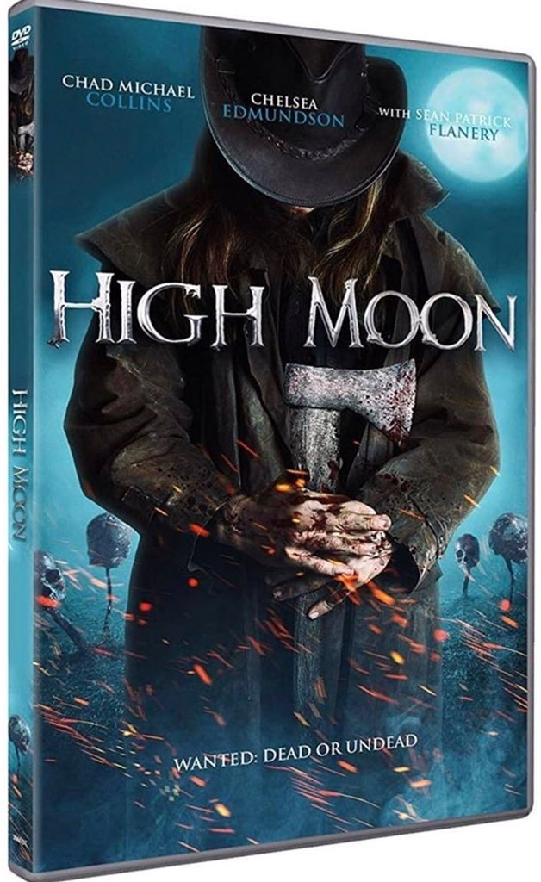
LOS ANGELES, CA - Sharpen the axes and load the silver bullets for HIGH MOON round 2! Things are about to get messy (again) when a cowboy gunslinger awakens in the modern day, just in time to take down a gang of vicious werewolf bikers – this time on DVD after a successful run on VOD/Digital earlier this spring!

Written and directed by Josh Ridgway (Lionsgate’s THE SECTOR), the film stars Chad Michael Collins (Sony’s SNIPER military action franchise, CALL OF DUTY: MODERN WARFARE 2019) alongside co-stars Sean Patrick Flanery (SAW 3D, BOONDOCK SAINTS), Chelsea Edmundson (DAYLIGHT’S END, THUNDER ROAD), and Matthew Tompkins (SICARIO). HIGH MOON is “BLADE from the old west," inspired by the classic ‘80s / ‘90s camp creature features from John Carpenter and Fred Dekker.

Colt (Chad Michael Collins)—a gunslinging werewolf slayer from the old west—mysteriously rises from the grave, only to find that the band of werewolves that brutally murdered his wife are still running rampant generations later. Aided by a beautiful widow (Chelsea Edmundson), a skeptical town sheriff (Matthew Thompkins) and a corrupt Mayor (Sean Patrick Flanery), Colt must face off with the bloodthirsty creatures once again to save a sleepy southern town from destruction.

The DVD for HIGH MOON is currently available for pre-order on Amazon, and in such retail giants as Wal-Mart, Target, Best Buy, Fry’s, and Barnes & Noble with availability on RedBox in the near future.

Filmed in and around Dallas, Texas, HIGH MOON (formerly titled HOWLERS) is being distributed by Distribution Solutions / Alliance Entertainment and Archstone Distribution. Producers are Rishi Chitkara, Josh Ridgway, and Chad Law. Executive Producers include Larry LeMaster, Heath Calhoun, and Greg Fussell. Lead actor Chad Michael Collins is also an Associate Producer.

Keep up with the latest by visiting the official website, www.HIGHMOONtheMovie.com, or following any of the official social media accounts:

HIGH MOON on Facebook
HIGH MOON on Twitter
HIGH MOON on Instagram
HIGH MOON on IMDB

About Distribution Solutions

Distribution Solutions, a division of Alliance Entertainment, is the largest aggregator and downstream distributor of independent film labels in North America.

Distribution Solutions has extensive experience in home entertainment sales and distribution, including Physical Distribution (DVD/BLU-RAY/4K), Digital Distribution (TVOD, SVOD, AVOD,) and Global Television Distribution for a variety of content providers, including Magnolia Pictures, RLJ Entertainment and Archstone Distribution.

Distribution Solutions also offers comprehensive marketing and creative services, scaled to meet the needs of our partners.

About Alliance Entertainment Corporation

Alliance Entertainment is the largest wholesale distributor of physical home entertainment consisting of audio and video software in the United States, as well as newly added video games, selling to mass merchant retail, brick and mortar stores, internet retailers, independent store owners offering vendor managed or 3PL services.

With more than thirty years of distribution experience, Alliance Entertainment serves customers of every size, providing a robust suite of services to resellers and retailers worldwide.

Alliance Entertainment is a One-Stop solution for all entertainment product needs. As a solutions-based operation, Alliance Entertainment drives sales for companies with unparalleled selection and cost-efficient processing. Alliance Entertainment is headquartered in Sunrise, FL, with offices located throughout the U.S.

Visit http://www.aent.com for additional information on Alliance Entertainment.

Contact

For complete cast list, theatrical trailer, set stills and more, please visit the official HIGH MOON website:

www.HighMoontheMovie.com

To view the trailer, please visit:

https://youtu.be/4N2YQyA2etY

For More Information, Media Screeners, and Interviews:

Gunslinger Films, LLC
info@highmoonthemovie.com

Brigid Margeson
Brigid@teamclick.com

